**(Cover Page Image)**

**DSC5101 Group Assignment 2**

A Relook at “Risk Targeting and Policy Illusions – Evidence from the Announcement of the Volcker Rule”



**November 3, 2019**

Group Members

Utkarsh Chaturvedi ( )

Dasol Kim ( )

Shengnan Sang ( )

Nikhil Thomas ( )

Table of Contents

**1** **Executive Summary** 2

**2** **Understanding Trading Asset Ratio** 2

**3** **Study of variations in Trading Asset Ratios** 3

3.1 Preliminary View 3

3.2 Baseline Model & Equation 3

3.3 Conclusion(s) 3

3.3.1 Impact on banks 4

**4** **Robustness Tests** 4

**5** **Summary & Recommendations** 5

**6** **Appendix** 6

6.1 References 6

6.2 Figures 6

6.3 Tables 10

6.4 Non-linearity Tests 12

6.5 Placebo Test 13

6.6 Fixed Effect Tests 13

# **Executive Summary**

Enacted into law on July 21, 2010, the Dodd-Frank Wall Street Reform and Consumer Protection Act (“Dodd-Frank Act/DFA”), also referred to as the Volcker Rule, prohibits any banking institution from a) engaging in short-term proprietary trading of securities, derivatives, commodity futures and options; b) owning and sponsoring hedge funds or private equity funds. In wake of the 2008 global financial crisis, the Volcker Rule’s primary goal was to enhance banks’ safety and soundness through minimizing exposure to non-banking capital market risks. Exemptions were provided for specific activities including a) underwriting, market making-related, risk-mitigating hedging, trading of government obligations and other activities that improve the U.S. financial stability; b) investing in general corporate purpose companies such as foreign public funds, wholly-owned subsidiaries, joint ventures, acquisition and securitization-related vehicles. Note that an effective implementation of the regulation remained to be seen until 2016 due to the lag in agreement among regulatory agencies as well as the provision of a two to five-year conformance period.

This report will focus on the construction of linear regression model that incorporates an interaction variable, controlling covariates, and fixed time effects. Specifically, results produced from the above model demonstrate several key findings.

1. First, after the announcement of the Volcker Rule, banks decreased their trading assets
2. Second, banks that had significant trading asset ratios before DFA responded to the regulation the most, while this effect was not pronounced for those with low pre-DFA trading asset ratios
3. Finally, robustness tests suggest that the findings are beneficial to both the banking entities and regulatory bodies

# **Understanding Trading Asset Ratio**

Trading Asset ratios is used as a measurement metric to understand the effect that DFA (Volcker Rule) had on banking business. The Volcker Rule limited certain banking activities such as proprietary trading that were termed as “risky investments”. The Trading Asset Ratio is defined as the ratio of Trading Assets to Total Assets of the BHC – hence a higher Trading Asset Ratio becomes unfavorable to the current banking regulations. The following figure *(Fig. 1)* represents the distribution of banks based on their trading ratios. We observe from this figure, that a significant majority of banks did not have any trading assets (within the given data).

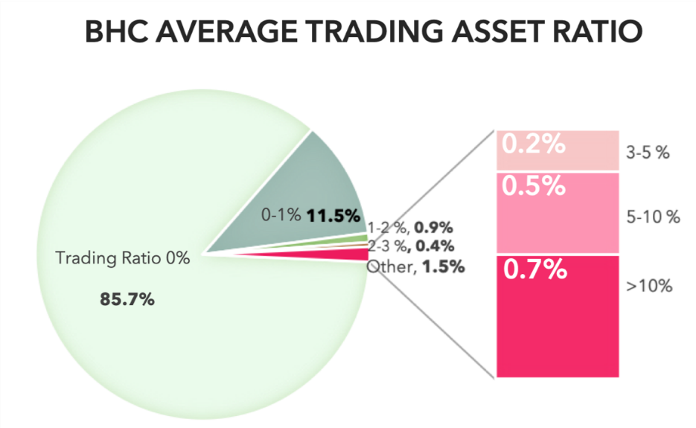

Fig. 1

Note that 41,442 missing observations have been omitted for simplicity.

# **Study of variations in Trading Asset Ratios**

**Assumption 1:** Bank holding companies with traditionally relatively large trading books pre-DFA will have the most impact and display substantial reaction to the Volcker Rule.

**Hypothesis 1:** *The affected banks started to reduce their trading asset ratio after the announcement of the Volcker Rule (Jussi Keppo, Josef Korte, 2016).*

## Preliminary View

Initial preliminary models were run with regressing Trading Asset Ratio’s against the DFA Flag (with and without control variables), however these led to insignificant results and showed that there was no effect that DFA had on Trading Asset Ratios. *(Fig. 2.1 & 2.2)*

## Baseline Model & Equation

To better understand the effect of the Volcker Rule, a more extensive model is defined that is truly able to gauge the impact that the Volcker Rule had on trading asset ratios post the implementation of the new regulations.

To understand this effect, we have used a simple regression model with the following equation –

* ***TradingAssetRatio***is the BHC’s trading asset ratio in each quarter from 2004 to 2015, which is modelled in this analysis
* A variable has been engineeredasbinary variable, to indicate the pre-post time of DFA coming into effect
* Variable is has been calculated as the average trading asset ratio from third quarter 2004 to second quarter 2009
* Interaction variable was created between these 2 variables. **Control Variables** and **Fixed Effects** of **BHC & Time**[1] were added to make the model robust
* For the list of control variables used, refer Table 1.1 in the Appendix

## Conclusion(s)

[3]

[3]

[2]

[2]

Fig. 2.2

Fig. 2.3

Fig. 2.4

Fig. 2.1

With the addition of the *Affect* (pre-DFA trading ratio) and the interaction variable of DFA implementation flag and *Affect*, the model hopes to better capture the magnitude and significance of implementation of the Volcker Rule. Two critical results are observed *(Figure 2.3 & 2.4):*

1. The interaction variable *Affect*DFA_Flag* has a significant negative coefficient of high magnitude, which is consistent with **hypothesis 1**, and has been discussed in detail in Section 3.3.1

[1] Test to confirm the necessity of time as Fixed Effect are in Appendix section 6.6

[2] The coefficient refers to the estimate of DFA_Flag

[3] The coefficient refers to the estimate of interaction affect: DFA_Flag*Affect

1. *Affect* is found to be a significant with a positive coefficient – implying that BHC’s with high trading asset ratios before the Volcker Rule continue to have relatively high trading asset ratio after the implementation of the rule as well

**Testing for non-linear trends:**

To check for non-linear trends, squared values of *Affect* variable was added into the model, to check if any non-linear trends are present or can be captured. While the results of this iteration(s) corroborate the conclusion above, no evidence was found that a non-linear trend of reduction in trading ratio exists. *(Refer Section 6.4)*

### Impact on banks

Thus establishing that Volcker Rule has had an effect on the trading ratios of banks, the magnitude of impact on these banks becomes the next critical question. Observing the coefficient value of interaction variable *(Affect*pre_DFA_flag) in Fig. 2.3 & 2.4*, it is found to be significant & negative.

The coefficient is particularly interesting in the way it’s interacting with *Affect*. An interpretation of this interaction coefficient could be that as ‘*Affect’* value increases (i.e. for banks having higher pre-DFA trading ratio), the magnitude of drop in trading ratios is higher. E.g. for banks with 0.1% average pre-DFA trading ratio, the magnitude of effect of DFA would be *(-0.1%*16.1%),* but for banks with 10% pre-DFA trading ratio, the magnitude is *(-10%*16.1%).*

The interaction variable with fixed effects *(Fig. 2.4)* tries to improve upon this phenomena even further. Since BHC’s have been controlled along with period, the *Affect* variable is now acting as a counter-factual for treatment group during the post-DFA period.

Hence, it can concluded conclude that, if the pre-trading ratio of banks are higher *(‘Affect’),* the implementation of DFA has had a more pronounced impact. This conclusion is further validated when banks are classified as “treated” with pre-DFA trading ratio thresholds of 2%, 3%, 5%, 10% and >10%[4]. The magnitude of interaction *DFA*Treatment Group,* when adjusted with control variables and fixed effects of BHC and time is in the table *(Table 1)* below:

|  |  |  |  |  |  |  |  |
| --- | --- | --- | --- | --- | --- | --- | --- |
| **Parameter** | 0.5% | 1% | 2% | 3% | 5% | 10% | 15% |
| Coefficient | -0.012 | -0.015 | -0.022 | -0.023 | -0.032 | -0.029 | -0.047 |
| p-value | <0.05 | <0.05 | <0.05 | <0.05 | <0.05 | <0.05 | <0.05 |

Table 1

# **Robustness Tests**

In order to ensure that the results and conclusion in Section 3.3 are indeed coherent and robust, control variables and fixed effects were incorporated into all models. Furthermore, various tests of robustness were performed, which included difference-in-differences and propensity score matching techniques.

1. After running a difference-in-differences model with only bank holding companies that had pre-DFA trading asset ratios greater than or equal to 3% as the treatment group, the model still yielded significant coefficients of -0.023 *(Fig. 3.1)*
2. Propensity score matching (with replacement) was used for matching control groups with 18 treated BHC’s, which ultimately resulted in coefficients of approximately -0.029 *(Fig. 3.2)*

The propensity matching exercise leads to better matched samples in the test and control[5] which further reinforces the results and prevents any reason of their being bias in the data – since the propensity matching was done with the first quarter of the data for all BHCs based on a vector created by the control variables.

The two robustness tests above indicate the effectiveness of the Volcker Rule based on banks’ trading asset ratio. However, it should be noted that the model assumes all else to be held constant. This is not necessarily always the case since banks may be driven to modify their business models after the 2008 financial crisis. Consequently, the following additional tests are carried out:

[4] These thresholds were created to ensure 9-10 banks are added at each threshold [except 0.5% & 2% threshold]

[5] Refer to section 6.3 for more information on the groups

1. Account for banks’ asset trading ratios pre-DFA *(Fig. 3.3)*
2. Remove bank holding companies that had 0 trading asset ratio pre-DFA *(Fig. 3.4)*

Overall, it is confirmed that our conclusions produces strong and robust results: banks decreased their trading asset ratios after the announcement of the Volcker Rule.

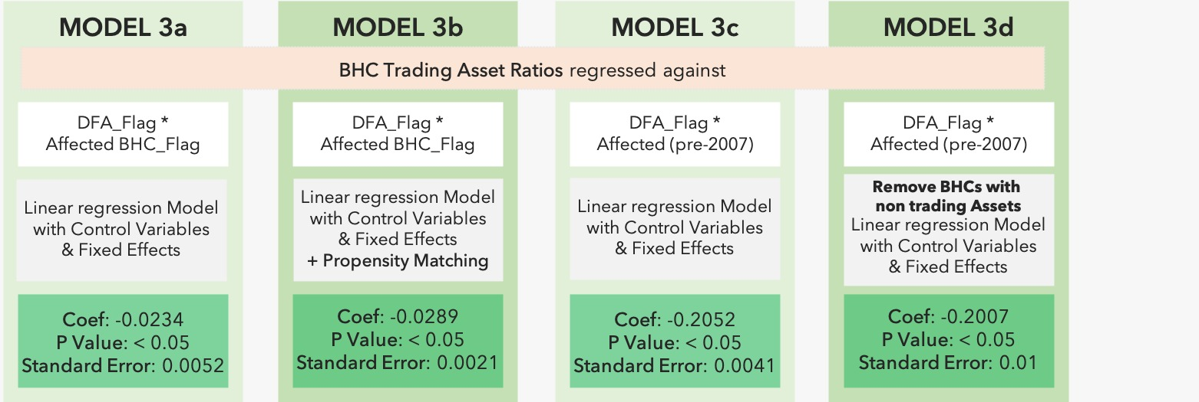

Fig. 3.2

Fig. 3.1

Fig. 3.4

Fig. 3.3

A final Placebo test is performed to test the robustness of conclusion that: More affected banks have higher reduction in trading asset ratio after introduction of Volcker Rule (Refer Section 6.5).

# **Summary & Recommendations**

Overall, the results indicate that the Volcker Rule effectively steered a decrease in banks’ trading asset ratios, of which banking entities with predominant trading activities prior to the announcement demonstrated stronger reactions to the regulation. Note that the majority of bank holding companies had close to zero or insignificant trading asset ratios preceding the Dodd-Frank Act. This further warrant robustness testing in order to evaluate the strength of statistical model in the treatment and control groups.

These findings are meaningful for both the financial institutions and its regulatory authorities. Authorities such as the Basel Committee on Banking Supervision and the International Association of Insurance Supervisors concurred and delineated a list of global systematically important banks “G-SIBs”. Historically, such banks maintain considerable equity trading portfolios, and in accordance to the model implications, responded the most after the announcement of the Volcker Rule. Hence, separate regulatory compliance requirements should be imposed on the peer groups. Concurrently, smaller financial institutions will be categorized into another peer group based on factors including total amount of assets, cross-jurisdictional network and reach, interconnectedness, infrastructure, and complexity and diversification of transaction activities. Specifically, risk-based “CAMELS” monitoring system is an ideal barometer for assessing bank entities’ overall well-being. The scoring test is comprised of “Capital Adequacy”, “Asset Quality”, “Management”, “Earnings”, “Liquidity”, and “Sensitivity to Market Risk”. Among all factors within the framework, management of internal market and liquidity risks is key to improving the bank entities’ resiliency. It should be emphasized that smaller-sized banks be subject to more flexibility in terms of business lines and risk levels.

In addition to suitable monitoring frameworks upheld by regulatory agencies, the bank entities themselves should aim to enhance current capital allocation optimization models and undertake self-regulation to a certain degree. In fact, the analysis indicates that while affected bank holding companies reduced trading asset ratios after announcement of the Volcker Rule, the asset return volatility has significantly increased, and thus, banks were able to maintain their target risk ratios.

# **Appendix**

## References

1. Risk Targeting and Policy Illusions – Evidence from the Announcement of the Volcker Rule,

*Jussi Keppo & Josef Korte (2016)*

1. The Federal Deposit Insurance Corporation. *Deposit Insurance Assessments.* Retrieved October 25, 2019 from <https://www.fdic.gov/deposit/insurance/assessments/risk.html>
2. Federal Reserve Economic Data (FRED) by the Federal Reserve Bank of St. Louis. *The ABCs of CAMELS.* Retrieved October 25, 2019 from <https://www.stlouisfed.org/on-the-economy/2018/december/camels-ratings-liquidity>
3. The Federal Reserve Board of Governors. *Trading Activities at Systemically Important Banks, Part 3: What Drives Trading Performance?* Retrieved October 25, 2019 from <https://www.federalreserve.gov/econres/notes/feds-notes/trading-activities-at-systemically-important-banks-part-3-what-drives-trading-performance-20170710.html>

## Figures

**Model 1a:**

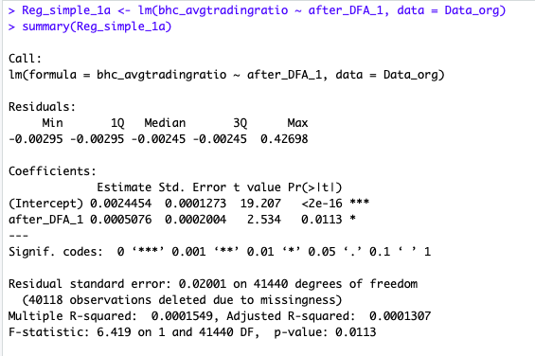

**Model 1b:**

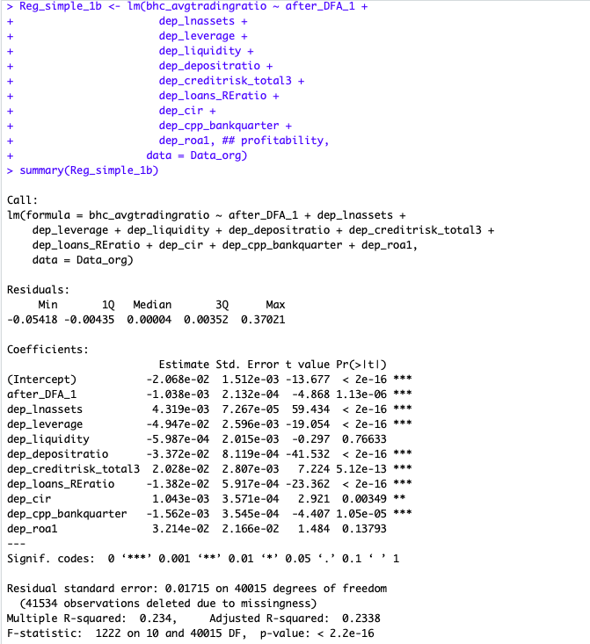

**Model 2a:**

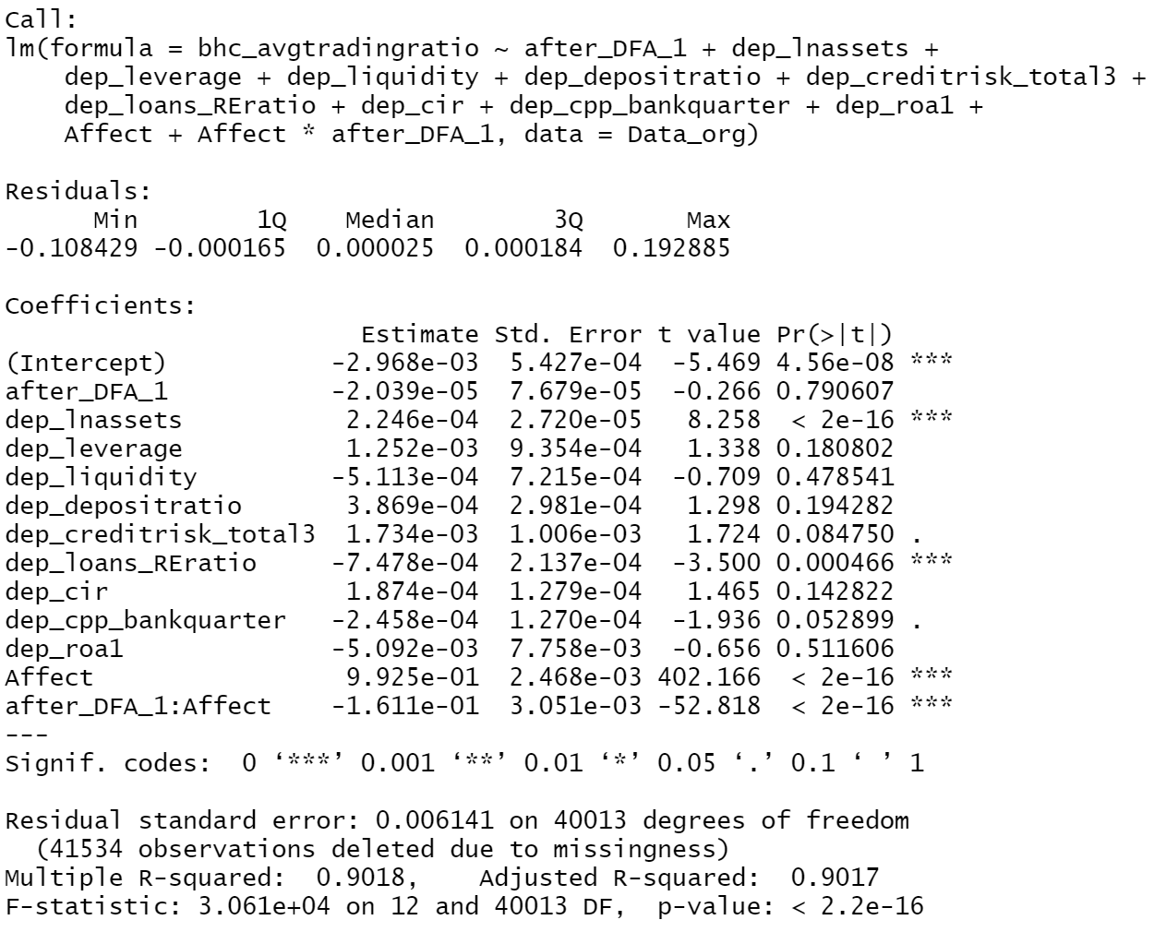

**Model 2b:**

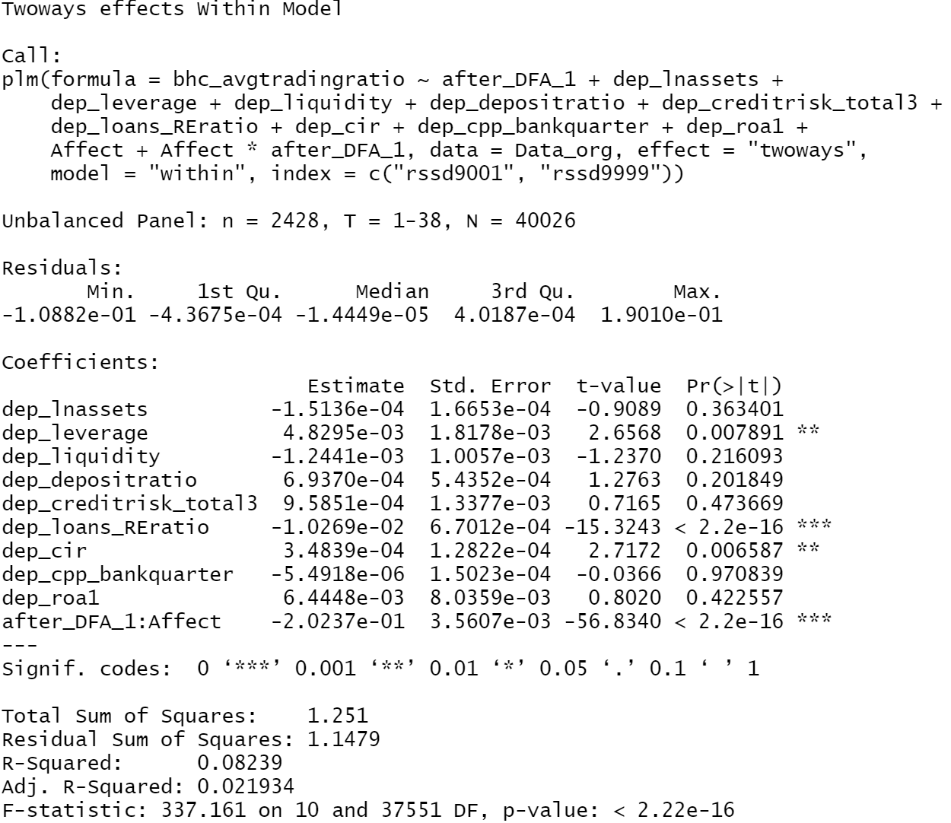

**Model 3a:**

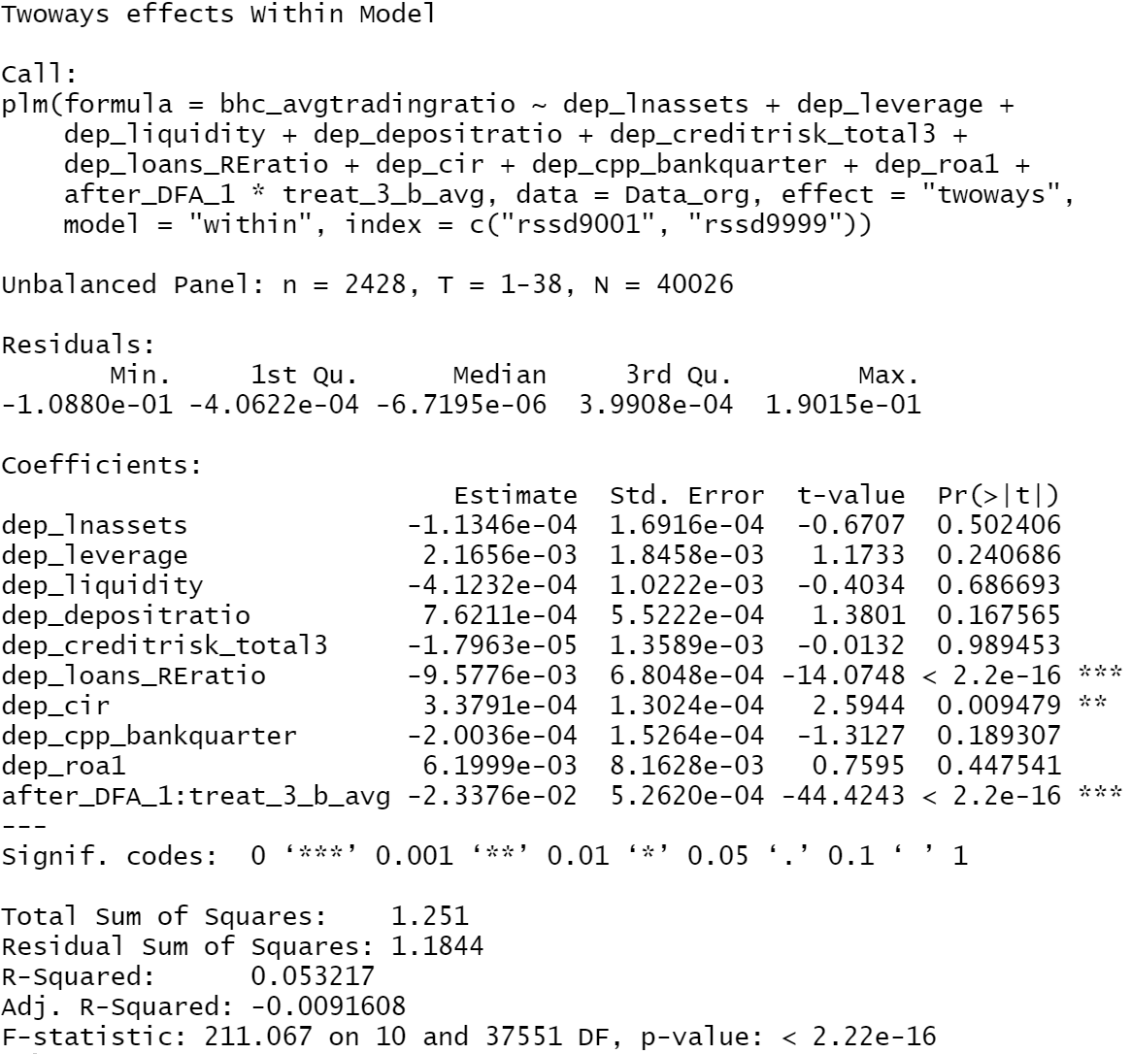

**Model 3b:**

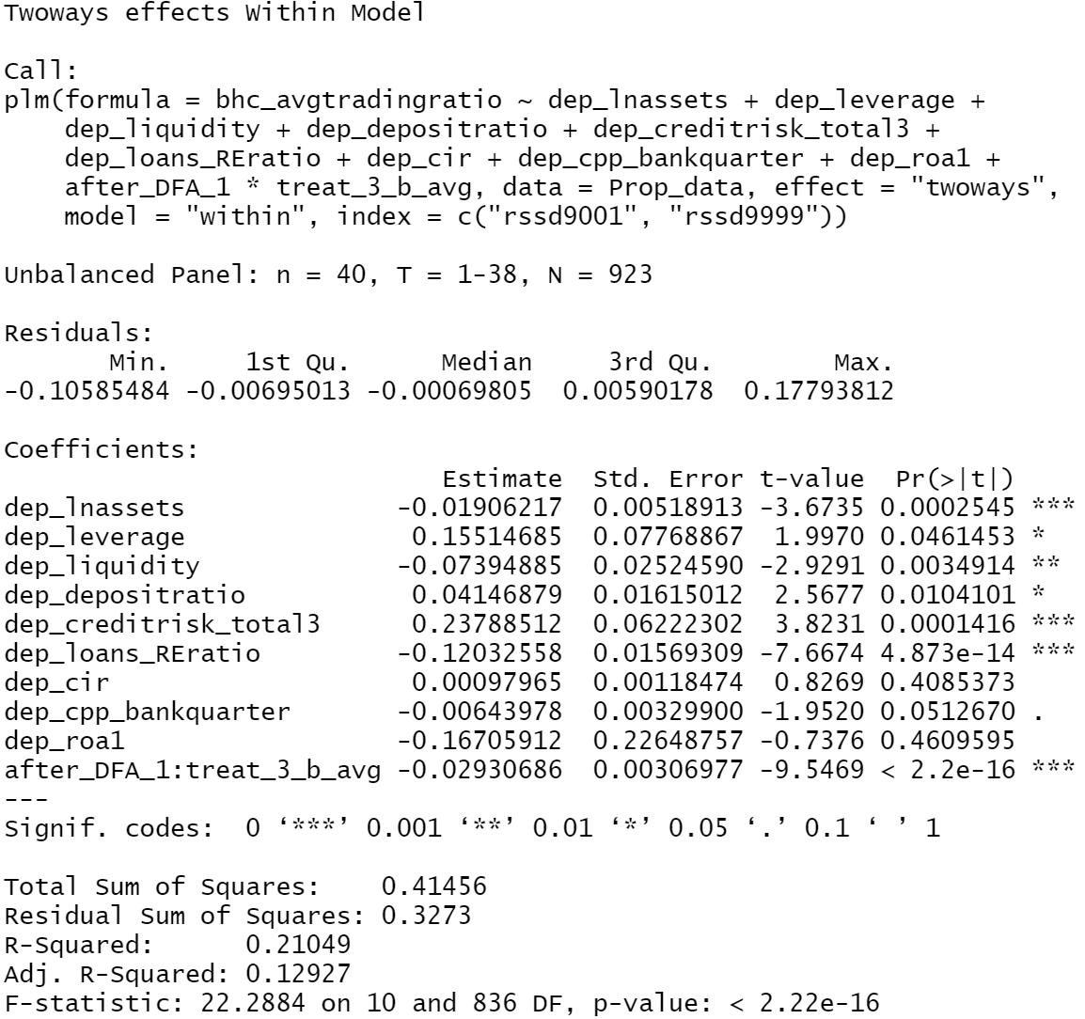

**Model 3c:**

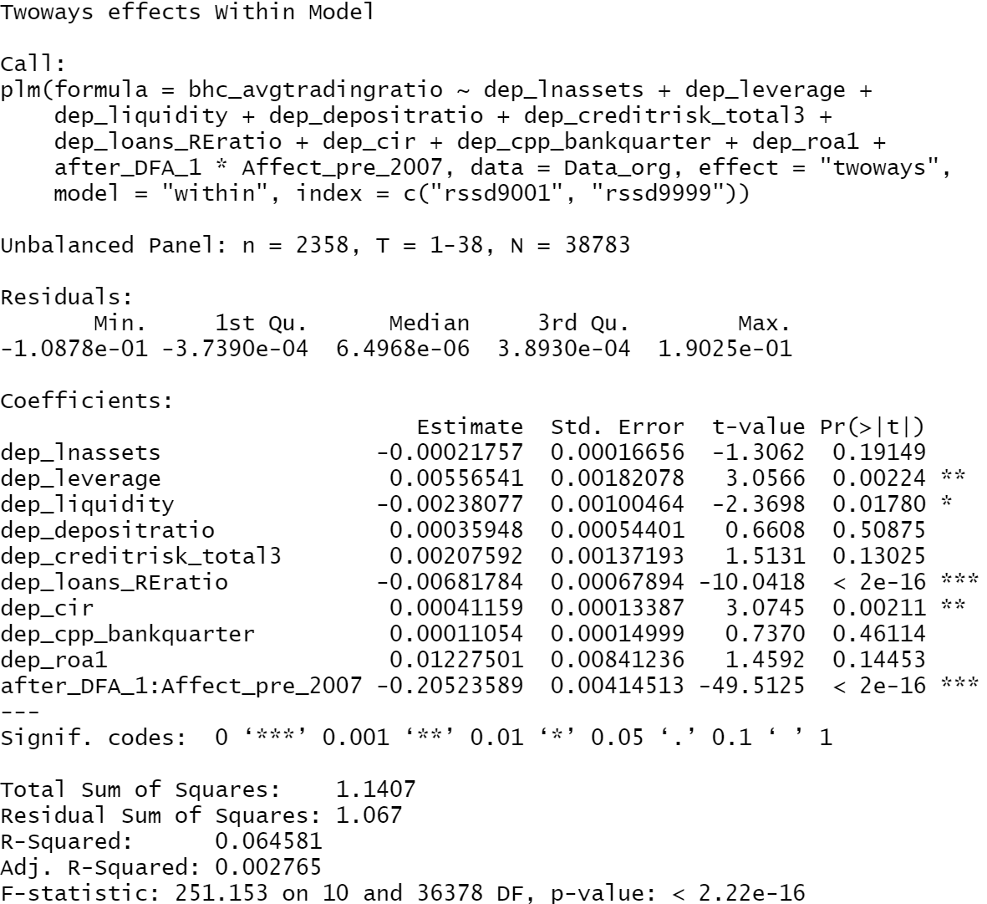

**Model 3d:**

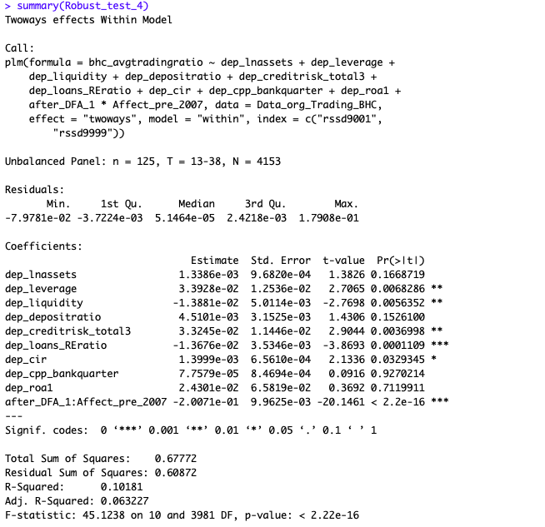

## Tables

1. **List of control variables:**

|  |  |
| --- | --- |
| Total assets | Natural logarithm of total assets |
| Leverage ratio | Average equity divided by average total assets |
| Profitability | Net income divided by average total assets |
| Liquidity ratio | Cash and balances at other depository institutions divided by total assets |
| Deposit ratio | Average deposits divided by average total assets |
| Cost-income ratio | Operating expenses divided by total income |
| Nonperforming loan ratio | Past due and nonaccrual loans divided by total loans |
| Real estate loan ratio | Loans secured by real estate divided by total loans |
| CPP recipient indicator | Capital Purchase Program indicator binary variable |

1. **Propensity Matching:**

Before Matching:

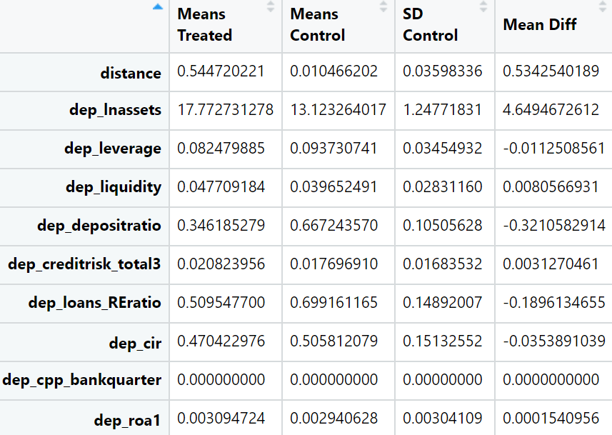

After Matching:

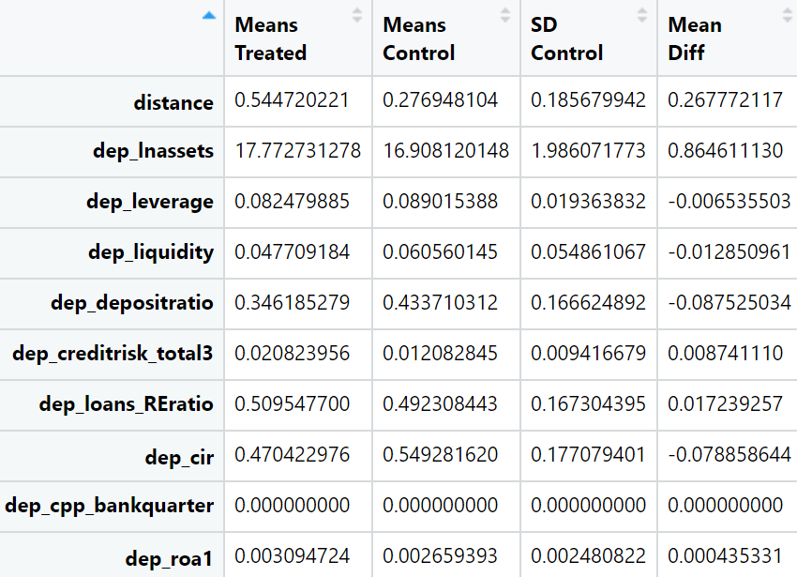

## Non-linearity Tests

**Non-linearity test (with FE):**

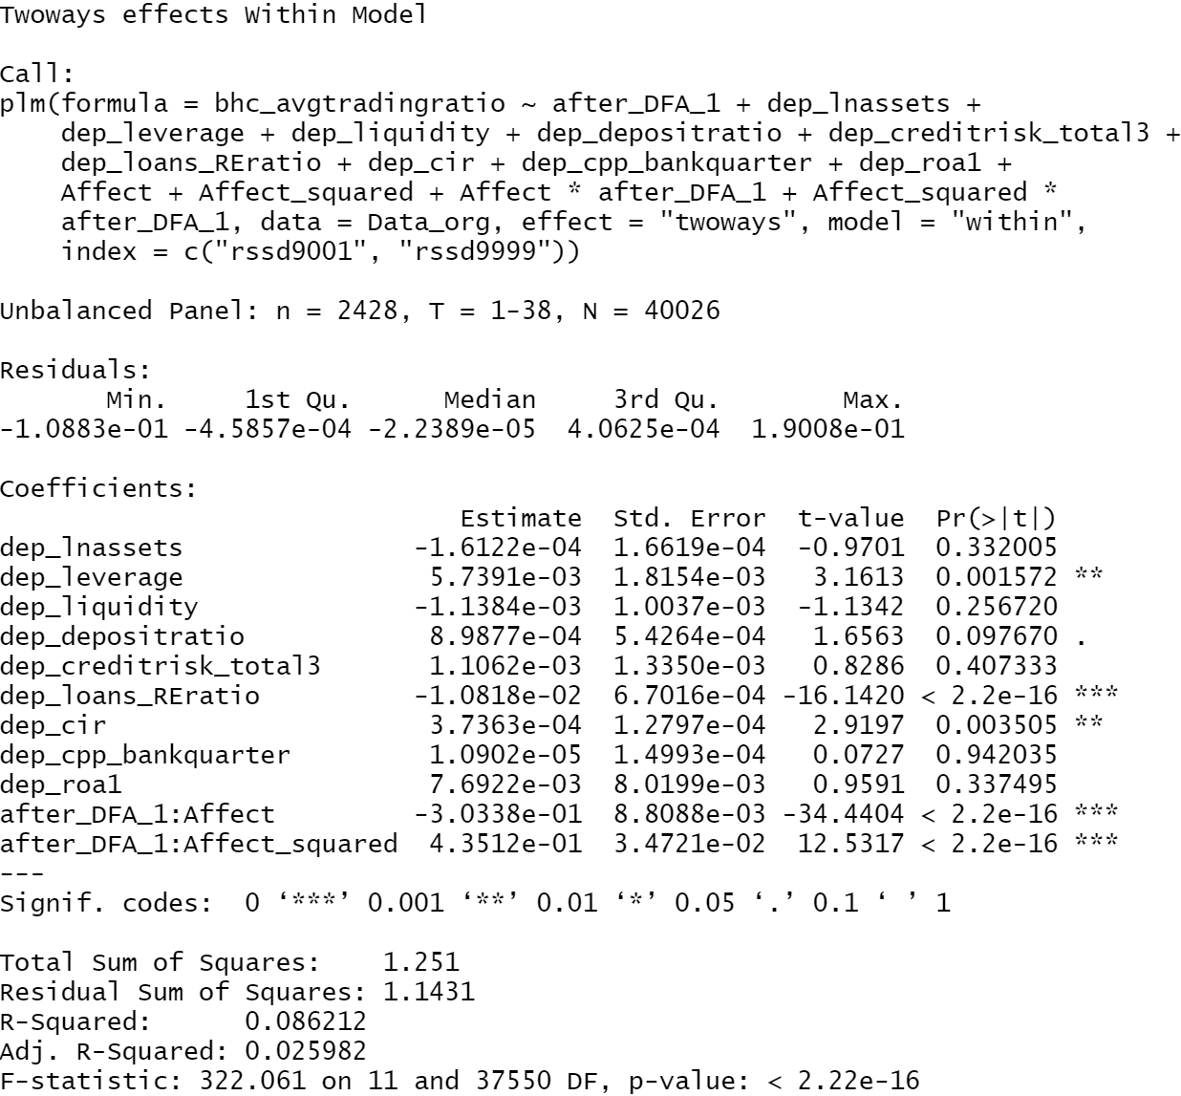

**Non-linearity test (without FE):**

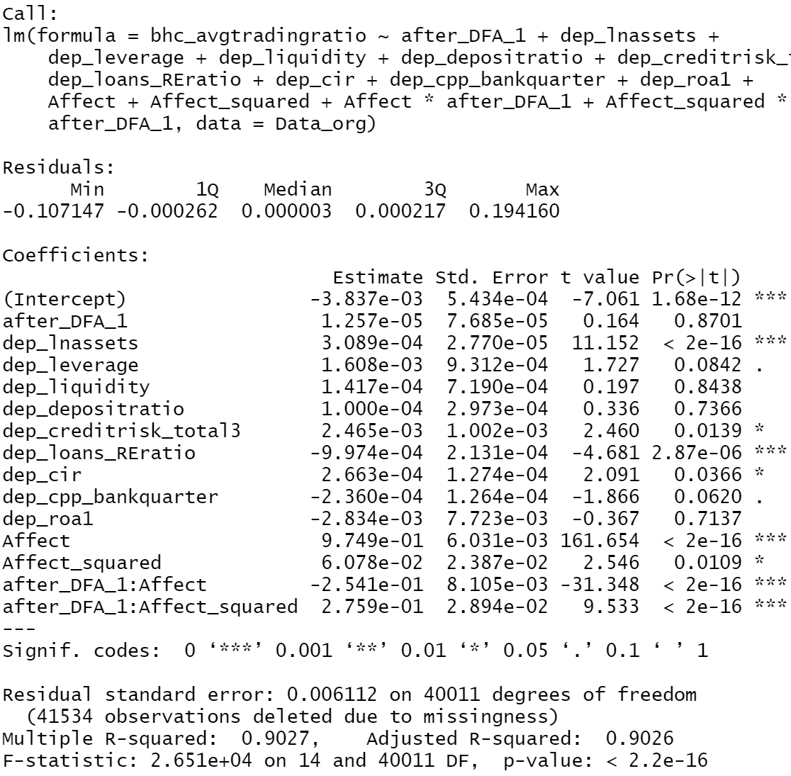

## Placebo Test

Placebo test was conducted to ensure that effect observed on treatment group is indeed due to Volcker Rule. In this test, treatment & control groups are randomly assigned across pre-DFA period of 1st quarter 2007 to 2nd quarter 2009, each quarter. The coefficient of interaction variable *DFA_Flag*Treatment Group* is then measured via repeated sampling of non-trading BHC’s within the quarters specified above and regressed across the data-period.

Below is the distribution of the coefficients for randomly assigned treatment/control group (sample of 1100 iterations):

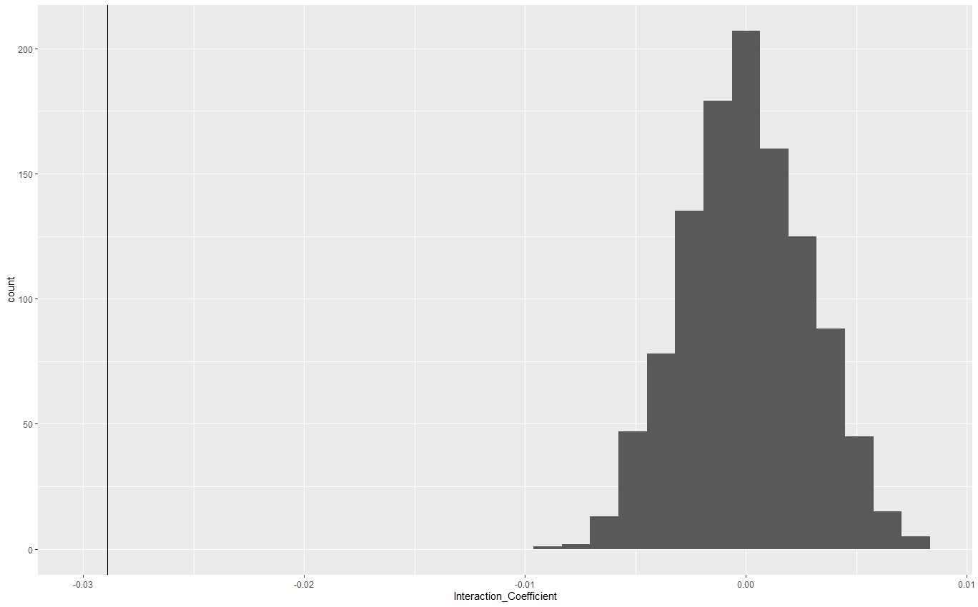

Frequency

Estimate of Interaction coefficient

## Fixed Effect Tests

**Testing for Fixed vs. Random Effects**

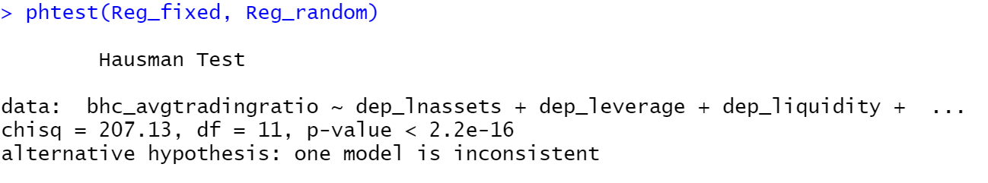

With p-value<0.05 for Hausman test, we can conclude that fixed effects should be used.

**Testing for necessity of time in Fixed Effects**

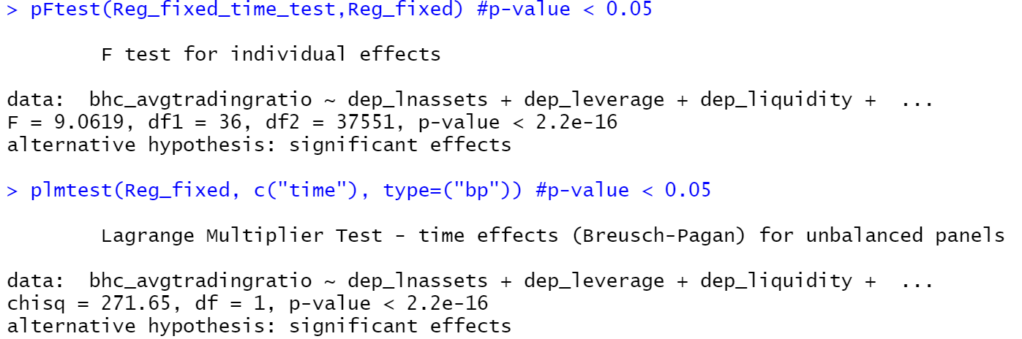

From the tests above, we can conclude that time fixed effects are necessary.